Smart Walking Stick For Blind Using Arduino

# Karthikeyan. S1, Kevin Prince Jayaraj.D2, S.A.K. Jainulabudeen3

1, 2 Dept of computer science and engineering

3Assistant Professor, Dept of computer science andengineering,

1, 2, 3 panimalar Engineering College, Tamil Nadu,India

***Abstract-*** *This paper describes unsounded blind walking keep on with the use of arduino. keep with UN agency, thirty million peoples unit of mensuration for good blind and 285 billion peoples with vision impairment . If u notice them , you may alright fathom it they can’t walk whereas not the assistance of varied. One possesses to spice up steering to achieve their destination. they need to face an excellent deal of struggles in their life traditional of living. observe this blind stick , a non-public will walk an excellent deal of with confidence. This stick detects the item before of the person and provides response to the user either by moving or through command. So, the person will walk with none concern. This device ar best resolution to beat their difficulties .*

***Keywords****-* Arduino, unsounded detector, Walking stick, GSM sensor, IR

# INTRODUCTION

This walking stick is another to the standard walking stick. Here, Arduino UNO , unsounded detector, IR sensor, voice playback module , liquid LCD |alphanumeric show} display and device unit of mensuration used. Arduino is additionally a microcontroller that may do all the calculations extremely quickly with nice accuracy. unsounded detector is used to look out the item among the front of the person by live the world between the item and then the stick. For left and right object detection, IR detector is used that is unbelievably little or no in vary. So, it detects the item that unit of mensuration extremely shut. observe an excellent deal of unsounded detector might manufacture calculation recoil. So, IR detector is most popular. The voice playback module can assist the visually individual to achieve the destination through the command or mike.

# METHODOLOGY

The operative behind this blind stick is that it's used for special purpose as a sensing device for the blind individuals. The circuit provides 5V power offer for the circuit and maintains its output of the flexibility give at constant level. It issued wide to look out objects observe unsounded detector and IR detector. If any object is gift, the unsounded detector detects the item by live the world between the item and then the user and sends the info to the arduino UNO. to work out the world of Associate in Nursing object , calculate

the world between effort the signal and receiving back the signal.

*Distance=speed*time

The speed of the signal traveling through air is 341m/s. The time is calculated between the trouble and receiving back the signal. Since the world elapse the signal is double, it's divided by 2 i.e.,

Distance=*Distance/2

IR detector is placed at right and left of the follow notice the item. Since, it's extremely little or no vary, it detects the nearer objects. Arduino processes with this knowledge and calculates with the command conditions. If any object is found nearer, it sends the command to the user through the speaker or mike. The command is already keep among the voice playback module that sends alert message to the user concerning the item. The command condition is as follows:

1. If the world between the objects and then the person is thirty in., it's progressing to send the command as a results of the obstacle is nearer to the person
2. If the item is concerning 60-90 in., it's progressing to send the command as a results of the obstacle is simply nearer and reaching the person.

# MODELING AND ANALYSIS

* 1. **ARDUINO UNOR3**

Arduino UNO is also a microcontroller board supported ATmega328p. it’s 20pins out of that sixteen digital input and output pins and vi analog input pins. 16MHZ quartz,power jack, ICSP header and button compare to PIC microcontroller ,its very straightforward to perform with Arduino since it’s user friendly. The Operation voltage is 5V,you will directly connect it to laptop with USB cable,power it with AC-DC adapter or battery

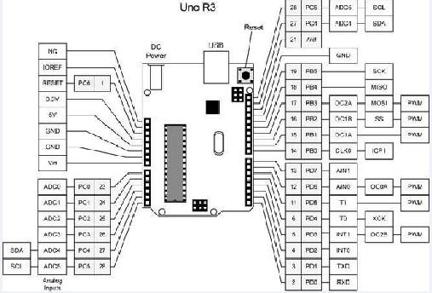

**Figure 1:** pin configuration of Arduino

# LDRSENSOR

A light-weight Dependent resistance(aka LDR, photoconductor, or photocell) is also a tool that comes with a resistance that varies in step with the quantity of sunshine falling on its surface. A typical light-weight dependent resistance is pictured on high of beside (on the right hand side) its circuit diagram image. Altogether completely (diferent) LDR’s have different specifications, however the LDR’s we tend to tend to sell inside the REUK search unit of measurement fairly commonplace and have a resistance in black of 1 M Ohm, and a resistance of a number of k Ohm in bright light-weight (10-20kOhm @ 10 lx, 2-4kOhm @ 100 lux).

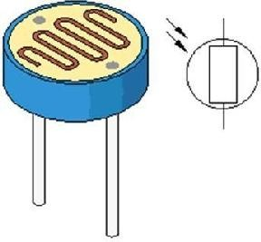

**Figure 2**: LDR sensor

# GSMSENSOR

International System for mobile communication (GSM) is also a globally accepted commonplace for digitalCellular communication. GSM is that the name of a common placeization cluster established in 1982 to create a typical European mobile phone commonplace that may formulate specifications for a pan-European mobile cellular radio system operative at 900 M rate. It’s denumerable that

many countries outside of Europe will be a part of the GSM partnership.

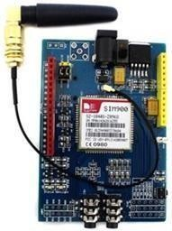

**Figure 3:** GSM sensor

# RESULTS AND DISCUSSION

The project encompasses a excellent scope in future yet as in gift. The project may be enforced with the various detector to guide the dim-sighted individuals within the world. the most theme of this project is to assist the blind individuals and build them to move with the physical world. In future this project may be developed by adding GSM module. The module were wont to track the situation of the blind individuals. The module were wont to track the situation of the blind individuals. The emergency button were placed facilitate

|to assist} them if they're in any danger or they have any help. Then the device were placed in their garments or hat to form the device additional transportable and simple to use by the blind individuals

.

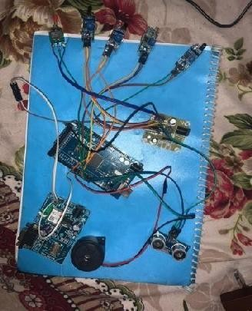

**Figure 4:** output

# CONCLUSION

The Blind Walking Stick has been finally created into epitome which might be wont to guide the blind . Its aims to unravel the issues featured by the blind individuals in their standard of living. The system conjointly takes the live to make sure their safety . This project can operate to assist all the blind individuals within the world to form them easier to steer all over they require. it absolutely was done to assist the blind to maneuver before alright. it's wont to facilitate the individuals with disabilities that ar blind to facilitate the movement and increase safety.

# REFERENCES

1. E. J. Chukwunazo and G. M. Onengiye “Design and Implementation of Microcontroller based mostly quality Aid for Visually Impaired folks.” International Journal of Science and analysis. Vol. 5, issue 6, pp. 680-686, 2015
2. O. O. Olakanmi, “A two-dimensional Walking Aid for Visually Impaired victimization supersonic Sensors Network with Voice Guidance", International Journal of Intelligent Systems and Applications (IJISA), vol. 6, number 8, pp.